

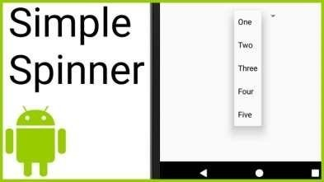

|  |
| --- |
| **BATCH AND ROLL NO: R6, 42257** |
| **EXPERIMENT NO.: 04** |
| **TITLE:** Design a mobile application to create registration application which having spinner (subject), radio button (gender), qualification (check box), first insert the  value and then show the data in show activity. |
| **DATE OF PERFORMANCE:** |
| **DATE OF CHECKING:** |

**Title:** Design a mobile application to create registration application which having spinner (subject), radio button (gender), qualification (check box), first insert the value and then show the data in show activity.

# Requirements:

1 Android studio

2. WordPress Themes and plugins.

# Theory:

In android, Spinner is a view that allows a user to select one value from the list of values. The spinner in android will behave same as a dropdown list in other programming languages.

Generally, the android spinners will provide a quick way to select one item from the list of values and it will show a dropdown menu with a list of all values when we click or tap on it. By default, the android spinner will show its currently selected value and by using Adapter we can bind the items to spinner objects. We can populate our Spinner control with list of choices by defining an Array Adapter in our Activity file. Generally, the Adapter pulls data from sources such as an array or database and converts each item into a result view and that’s placed into the list. Following is the pictorial representation example of simple spinner.

In android, Radio Button is a two-states button that can be either checked or unchecked and it’s the same as Checkbox control, except that it will allow only one option to select from the group of options. The user can press or click on the radio button to make it select. In android, Checkbox control allow users to change the state of control either Checked or Unchecked but the radio button cannot be unchecked once it is checked. Generally, we can use Radio Button controls in an android application to allow users to select only one option



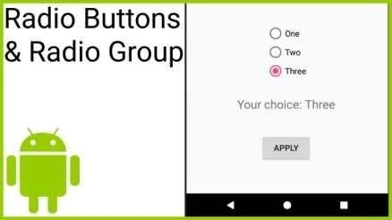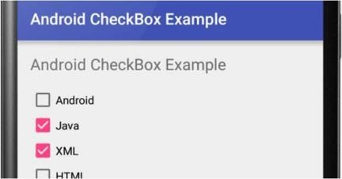

from the set of values. Following is the pictorial representation of using Radio Button control in android applications.

In android, Checkbox is a two-state button that can be either checked (ON) or unchecked (OFF) and it will allow users to toggle between the two states (ON / OFF) based on the requirements. Generally, we can use multiple Checkbox controls in android application to allow users to select one or more options from the set of values.

Following is the pictorial representation of using Checkbox control in android applications.

Here are the general steps to create registration form in Android Studio:

1. First, we create a new project and add an empty activity.
2. We use Constraint Layout for this sample, check for all the constraints after you finish.
3. Add simple spinner for subject.
4. Add radio button for gender.
5. Add check box for qualification.
6. After inserting the value and then show the data in show activity.



# Code:

<?xml version="1.0" encoding="utf-8"?>

<LinearLayout xmlns:android="<http://schemas.android.com/apk/res/android>" android:orientation="vertical" android:layout_width="match_parent" android:layout_height="match_parent" android:padding="16dp">

<TextView android:layout_width="wrap_content" android:layout_height="wrap_content" android:text="Omkar Phadke 42253" />

<TextView android:layout_width="wrap_content" android:layout_height="wrap_content" android:text="Name:" />

<EditText android:id="@+id/name_edit_text" android:layout_width="match_parent" android:layout_height="wrap_content" android:hint="Enter your name" />

<TextView android:layout_width="wrap_content" android:layout_height="wrap_content" android:text="Subject:" />

<Spinner android:id="@+id/subject_spinner" android:layout_width="match_parent" android:layout_height="wrap_content" />

<TextView android:layout_width="wrap_content" android:layout_height="wrap_content" android:text="Gender:" />

<RadioGroup android:id="@+id/gender_radio_group" android:layout_width="match_parent" android:layout_height="wrap_content" android:orientation="horizontal">

<RadioButton android:id="@+id/male_radio_button" android:layout_width="wrap_content" android:layout_height="wrap_content" android:text="Male" />

<RadioButton android:id="@+id/female_radio_button"

android:layout_width="wrap_content" android:layout_height="wrap_content" android:text="Female" />

</RadioGroup>

<TextView android:layout_width="wrap_content" android:layout_height="wrap_content" android:text="Qualification:" />

<CheckBox android:id="@+id/qualification_check_box_1" android:layout_width="wrap_content" android:layout_height="wrap_content" android:text="Bachelor's degree" />

<CheckBox android:id="@+id/qualification_check_box_2" android:layout_width="wrap_content" android:layout_height="wrap_content" android:text="Master's degree" />

<CheckBox android:id="@+id/qualification_check_box_3" android:layout_width="wrap_content" android:layout_height="wrap_content" android:text="PhD" />

<Button

android:id="@+id/register_button" android:layout_width="match_parent" android:layout_height="wrap_content" android:text="Register" />

</LinearLayout>



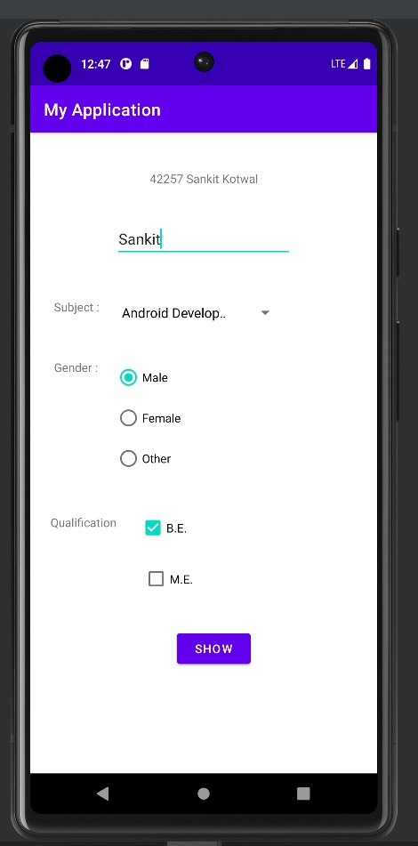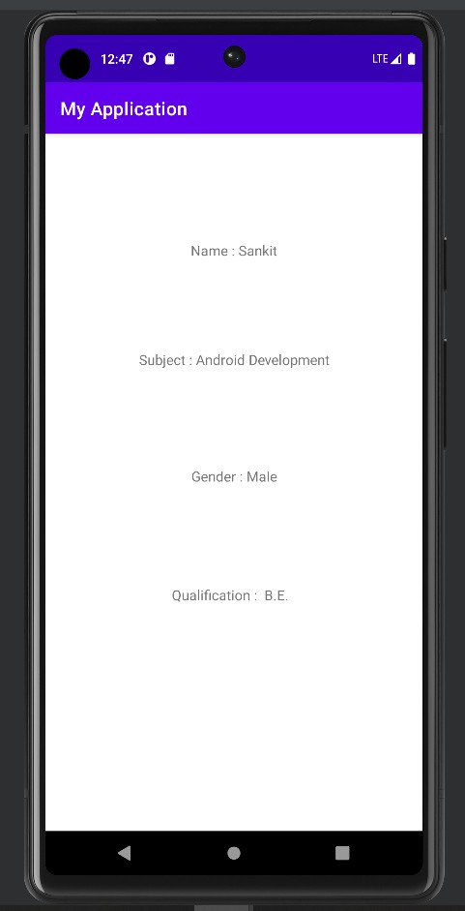

# Output:

**Conclusion:**

